**DATA BASE MANAGEMENT SYSTEM PROJECT**

**RAJA REDDY PUNDRA**

**197167**

**SUCHITH REDDY BILLA**

**197220**

**TITLE : RESTAURANT DATA BASE MANAGEMENT SYSTEM**

**PROJECT OVERVIEW**

The Restaurant database management system is to automate day to day activity of a restaurant. Restaurant is a kind of business that serves people all over world with ready-made food. This system is to provide service facility to restaurant and also to the customer. This restaurant management system can be used by employees in a restaurant to handle the clients, their orders and can help them easily find free tables or place orders. The services that are provided is food ordering and reservation table management by the customer through the system, customer information management and waiter information management, menu information management and report. After a successful login the customer can access the menu page with the items listed according to the desired time. The main point of this system is to help restaurant administrator manage the restaurant business and help customer for online ordering and reserve table. The user can search for a menu according to his choice i.e. according to price range and category of food and later he can order a meal.

Our main objective to design this project is to make a sustainability in restaurant services by creating a data base to it so that we can reduce the order processing time , digitalize the data and create a great customer experience .This leads to a great improvement in restaurant management and increases the profit of a restaurant

Our assumptions

* Restaurant works on day to day basis,(all items are renewed everyday).

DATABASE STRUCTURE

Our database contains total 12 tables out of it main tables are recipes, staff, bills and occupy and remaining tables all point to these tables using foreign key

|  |  |
| --- | --- |
| DATABASE TABLES | DESCRIPTION |
| Staff | This table consists all the staff id ,name and there personal information |
| Waiter | This is a weak entity set which maintains through a foreign key of staff id and it consists of there rating and work timings |
| chef | This is a weak entity set which depends on staff table by a foreign key of staff id and it give details of there positions |
| Others | This is also a weak entity set which maintains timings of other staff it has foreign key of staff id from staff table |
| Recipes | It contains all the recipes made in restaurant and there coast and id |
| Bills | This table give details of customer bills and the rating given to waiters |
| Occupy | This table tells us the customer they occupied table |
| Orders | This table gives us orders made by customers |
| Product_necessity | This table gives all the requirements for the recipes |
| Supplier | This table tells suppliers giving the product necessity |
| Tables | It gives all the table numbers |
| Payment mode | It gives different mode of payments |
|  |  |

**OVERALL EXPERIENCE**

**With this project we have learned overall experience of creating the complete data base management system and running it and also learnt how important database management system plays in our day to day life**

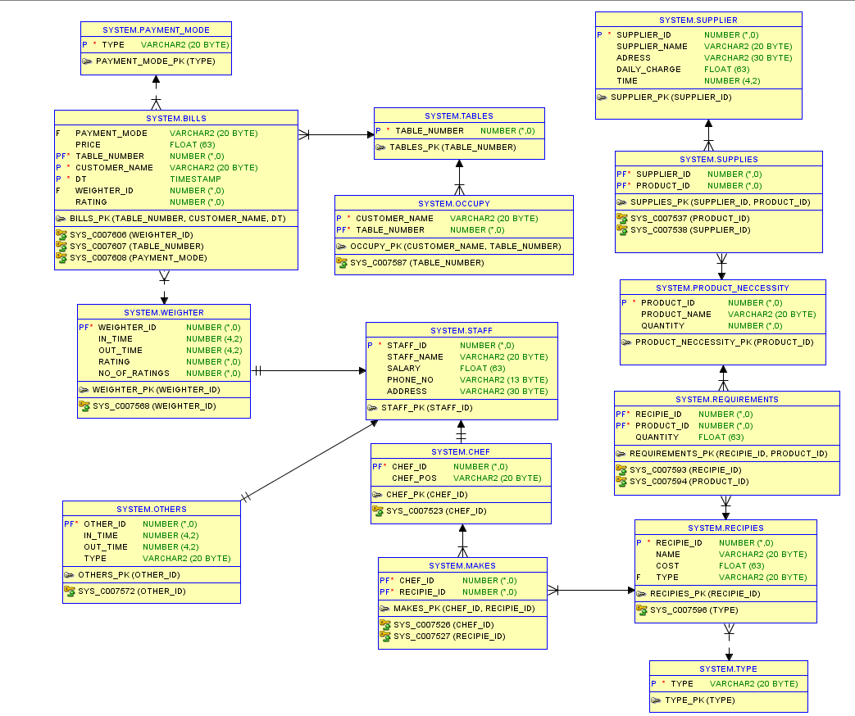**ER DIAGRAM**

(neglect the system prefix. Diagram is generated by SQL developer

To show that there is no difference between the actual ER and our database)

**TABLE STRUCTURE**

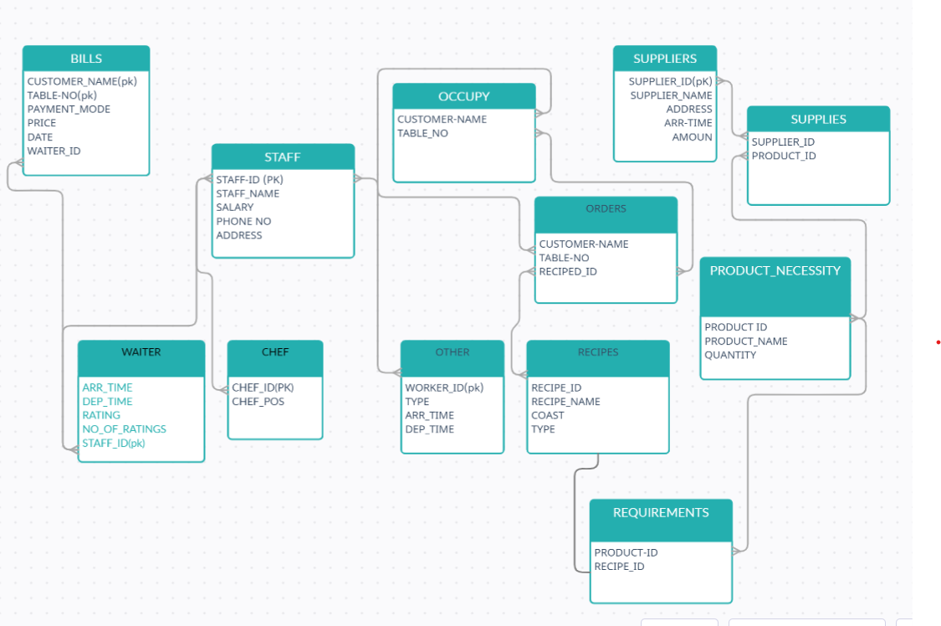

CREATION OF TABLES

staff

create table staff(staff_id int primary key,staff_name varchar(20),salary real,phone_no varchar(13),address varchar(30));

chef

create table chef(chef_id int primary key , chef_pos varchar(20),foreign key(chef_id) references staff(staff_id));

type

create table type(type varchar(20) primary key);

recipies

create table recipies(recipie_id int primary key,name varchar(20));

alter table recipies add(cost real);

alter table recipies add(type varchar(20),foreign key(type) references type(type));

makes

create table makes(chef_id int,recipie_id int,primary key(chef_id,recipie_id),

foreign key (chef_id) references chef(chef_id),foreign key (recipie_id) references recipies(recipie_id));

product neccessity

create table product_neccessity(product_id int primary key,product_name varchar(20),quantity int);

supplier

create table supplier(supplier_id int primary key,supplier_name varchar(20),adress varchar(30));

alter table supplier add(daily_charge real,time number(4,2));

supplies

create table supplies(supplier_id int,product_id int,primary key(supplier_id,product_id),

foreign key(product_id) references product_neccessity(product_id),foreign key(supplier_id) references supplier(supplier_id));

weighter

create table weighter(weighter_id int primary key,in_time number(4,2),out_time number(4,2),foreign key(weighter_id) references staff(staff_id));

ALTER TABLE WEIGHTER ADD (RATING INT);

alter table weighter add no_of_ratings int ;

others

create table others(other_id int primary key,in_time number(4,2),out_time number(4,2),foreign key(other_id) references staff(staff_id) ,type varchar(20));

requirements

create table requirements(recipie_id int,product_id int,foreign key(recipie_id) references recipies(recipie_id),foreign key(product_id) references product_neccessity(product_id),primary key(recipie_id,product_id));

alter table requirements add quantity real;

payment mode

create table payment_mode(type varchar(20) primary key);

tables

create table tables (table_number int primary key);

bills

create table bills(payment_mode varchar(20),price real,table_number int,customer_name varchar(20),DT TIMESTAMP,

WEIGHTER_ID INT,RATING INT, FOREIGN KEY(WEIGHTER_ID) REFERENCES WEIGHTER(WEIGHTER_ID),

foreign key(table_number) references tables(table_number),

foreign key(payment_mode) references payment_mode(type),PRIMARY KEY(TABLE_NUMBER,CUSTOMER_NAME,DT));

occupy

create table occupy(customer_name varchar(20),table_number int,

foreign key(table_number) references tables(table_number),primary key(customer_name,table_number));

orders

create table orders(customer_name varchar(20),table_number int,recipie_id int, quantity int,

foreign key(customer_name,table_number)REFERENCES occupy(customer_name,table_number),foreign key(recipie_id) references recipies(recipie_id),

unique(customer_name,table_number,recipie_id));

TRIGGERS ON TABLES

/

CREATE OR REPLACE TRIGGER BILLS

BEFORE INSERT ON BILLS

FOR EACH ROW

BEGIN

UPDATE WEIGHTER SET RATING=(RATING*NO_OF_RATINGS+:NEW.RATING)/(NO_OF_RATINGS+1) WHERE WEIGHTER_ID=:NEW.WEIGHTER_ID;

UPDATE WEIGHTER SET NO_OF_RATINGS=NO_OF_RATINGS+1 WHERE WEIGHTER_ID=:NEW.WEIGHTER_ID;

DELETE FROM OCCUPY WHERE :NEW.CUSTOMER_NAME=OCCUPY.CUSTOMER_NAME AND (:NEW.TABLE_NUMBER=OCCUPY.TABLE_NUMBER);

END;

/

create or replace trigger weighter

before insert

on weighter for each row

BEGIN

:NEW.no_of_ratings:=0;

:NEW.RATING:=0;END;

/

QUERRIES ON TABLES

INSERT INTO STAFF VALUES (831,'RAVI',10000,9390187654,'BHPL');

INSERT INTO STAFF VALUES (832,'RASHI',15000,9666599876,'HYD');

INSERT INTO STAFF VALUES (833,'RAHUL',11000,9831245678,'HYD');

INSERT INTO STAFF VALUES (834,'RUPA',12000,9786654123,'MANGALIGIRI');

INSERT INTO STAFF VALUES (835,'RAHEEM',18000,9873456789,'BHPL');

INSERT INTO STAFF VALUES (836,'SUBBA RAO',20000,9807653423,'KADAPA');

INSERT INTO STAFF VALUES (837,'SUHAS',16000,9367856243,'KHAMMAM');

INSERT INTO STAFF VALUES (838,'SOURAV',18000,9875634211,'RAMPUL');

INSERT INTO STAFF VALUES (839,'MANI',20000,9657845321,'JADCHERALA');

INSERT INTO STAFF VALUES (840,'SRINIVAS',50000,9086613457,'DELHI');

INSERT INTO STAFF VALUES (841,'JHON',45000,9879234511,'MADRAS');

INSERT INTO STAFF VALUES (842,'LAXMI',60000,9765534122,'HYD');

INSERT INTO CHEF VALUES (840,'MASTER');

INSERT INTO CHEF VALUES (841,'JUNIOR');

INSERT INTO CHEF VALUES (842,'GRAND MASTER');

insert into type values('soup');

insert into type values('starter');

insert into type values('biryani');

insert into type values('curry');

insert into type values('roti');

insert into recipies values(101,'Tomato Soup',80,'soup');

insert into recipies values(102,'Paneer Soup',85,'soup');

insert into recipies values(103,'chicken corn soup',100,'soup');

insert into recipies values(104,'Egg 65',120,'starter');

insert into recipies values(105,'Alu 65',120,'starter');

insert into recipies values(106,'Veg Spring rolls',160,'starter');

insert into recipies values(107,'Egg Nosile',120,'starter');

insert into recipies values(108,'veg cutlet',130,'starter');

insert into recipies values(109,'baby corn chilly',150,'starter');

insert into recipies values(110,'veg alewala',130,'starter');

insert into recipies values(111,'Chicken Biryani',260,'biryani');

insert into recipies values(112,'CHicken Biryani Fam',420,'biryani');

insert into recipies values(113,'Mutton Biryani',280,'biryani');

insert into recipies values(114,'Fish Biryani',240,'biryani');

insert into recipies values(115,'Prawn Biryani',300,'biryani');

insert into recipies values(116,'paneer butter masala',150,'curry');

insert into recipies values(117,'Dal punjabi',120,'curry');

insert into recipies values(118,'Veg sahi kurma',150,'curry');

insert into recipies values(119,'Mutton Curry',270,'curry');

insert into recipies values(120,'Fish Masala',240,'curry');

insert into recipies values(121,'Butter Chicken',220,'curry');

insert into recipies values(122,'Hyderabadi Chicken',220,'curry');

insert into recipies values(123,'Butter Naan',25,'roti');

insert into recipies values(124,'Tandori Roti',17,'roti');

insert into recipies values(125,'Rumal Roti',30,'roti');

insert into recipies values(126,'paneer paratha',240,'roti');

INSERT INTO PRODUCT_NECCESSITY VALUES (1,'CHICKEN',100);

INSERT INTO PRODUCT_NECCESSITY VALUES(2,'MUTTON',50);

INSERT INTO PRODUCT_NECCESSITY VALUES(3,'FISH',80);

INSERT INTO PRODUCT_NECCESSITY VALUES(4,'PRAWNS',60);

INSERT INTO PRODUCT_NECCESSITY VALUES(5,'BASMATI RICE',500);

INSERT INTO PRODUCT_NECCESSITY VALUES(6,'WHEAT FLOUR',300);

INSERT INTO PRODUCT_NECCESSITY VALUES(7,'CORN FLOUR',150);

INSERT INTO PRODUCT_NECCESSITY VALUES(8,'SEMOLINA',100);

INSERT INTO PRODUCT_NECCESSITY VALUES(9,'ALL PORPOSE FLOUR',200);

INSERT INTO PRODUCT_NECCESSITY VALUES(10,'BUTTER',150);

INSERT INTO PRODUCT_NECCESSITY VALUES(11,'ONIONS',50);

INSERT INTO PRODUCT_NECCESSITY VALUES(12,'PANNER',20);

INSERT INTO PRODUCT_NECCESSITY VALUES(13,'SPECIAL MASALA',15);

INSERT INTO PRODUCT_NECCESSITY VALUES(14,'GAS',2);

INSERT INTO PRODUCT_NECCESSITY VALUES(15,'MAZAA',5);

INSERT INTO PRODUCT_NECCESSITY VALUES(16,'SPRITE',5);

INSERT INTO PRODUCT_NECCESSITY VALUES(17,'THUMSPUS',5);

INSERT INTO PRODUCT_NECCESSITY VALUES(18,'FIZZ',5);

INSERT INTO PRODUCT_NECCESSITY VALUES(19,'CAPSICUM',5);

INSERT INTO PRODUCT_NECCESSITY VALUES(20,'CORRIANDER',20);

INSERT INTO PRODUCT_NECCESSITY VALUES(21,'MINT',20);

INSERT INTO PRODUCT_NECCESSITY VALUES(22,'CABBAGE',5);

INSERT INTO PRODUCT_NECCESSITY VALUES(23,'TOMATOES',5);

INSERT INTO PRODUCT_NECCESSITY VALUES(24,'CAULIFLOWER',5);

INSERT INTO PRODUCT_NECCESSITY VALUES(25,'egg',500);

INSERT INTO PRODUCT_NECCESSITY VALUES(26,'baby corn',5);

INSERT INTO PRODUCT_NECCESSITY VALUES(27,'Chillies',5);

INSERT INTO PRODUCT_NECCESSITY VALUES(28,'dal',5);

INSERT INTO PRODUCT_NECCESSITY VALUES(29,'all0',5);

insert into supplier values(401,'sneha non veg','bhpl',30000,09.000);

insert into supplier values(402,'durge rice depo','bhpl',12000,10.00);

insert into supplier values(403,'lakshmi WS','warangal',40000,06.00);

insert into supplier values(404,'amul','hyd',36000,04.00);

insert into supplier values(405,'hp gas','bhpl',1800,08.00);

insert into supplier values(406,'raja beverages','bhpl',2400,08.00);

insert into supplier values(407,'maruthi vegetables','bhpl',16000,05.00);

insert into supplier values(408,'Aachi masala service','manchureal',2000,03.00);

insert into requirements values(101,23,1);

insert into requirements values(101,21,2);

insert into requirements values(101,7,3);

insert into requirements values(102,12,2);

insert into requirements values(102,21,2);

insert into requirements values(102,7,7);

insert into requirements values(103,7,3);

insert into requirements values(103,10,4);

insert into requirements values(103,21,1);

insert into requirements values(104,13,1);

insert into requirements values(104,9,3);

insert into requirements values(104,25,1);

insert into requirements values(105,29,3);

insert into requirements values(105,13,1);

insert into requirements values(106,6,1);

insert into requirements values(106,7,5);

insert into requirements values(106,19,6);

insert into requirements values(106,20,7);

insert into requirements values(106,21,4);

insert into requirements values(107,25,1);

insert into requirements values(107,13,1);

insert into requirements values(107,24,1);

insert into requirements values(108,9,6);

insert into requirements values(108,20,1);

insert into requirements values(108,21,1);

insert into requirements values(108,22,1);

insert into requirements values(108,23,6);

insert into requirements values(109,27,1);

insert into requirements values(109,28,1);

insert into requirements values(109,13,3);

insert into requirements values(110,20,1);

insert into requirements values(110,21,1);

insert into requirements values(110,22,8);

insert into requirements values(110,23,2);

insert into requirements values(111,1,1);

insert into requirements values(111,5,9);

insert into requirements values(111,13,1);

insert into requirements values(111,21,5);

insert into requirements values(112,1,2);

insert into requirements values(112,5,5);

insert into requirements values(112,13,1);

insert into requirements values(112,21,5);

insert into requirements values(113,2,6);

insert into requirements values(113,5,4);

insert into requirements values(113,13,3);

insert into requirements values(113,21,1);

insert into requirements values(114,3,1);

insert into requirements values(114,5,2);

insert into requirements values(114,13,1);

insert into requirements values(114,21,1);

insert into requirements values(115,4,3);

insert into requirements values(115,5,1);

insert into requirements values(115,13,1);

insert into requirements values(115,21,4);

insert into requirements values(116,10,1);

insert into requirements values(116,12,6);

insert into requirements values(116,13,1);

insert into requirements values(116,14,6);

insert into requirements values(117,28,1);

insert into requirements values(117,10,2);

insert into requirements values(117,23,1);

insert into requirements values(117,13,1);

insert into requirements values(118,10,2);

insert into requirements values(118,21,1);

insert into requirements values(118,22,1);

insert into requirements values(118,23,1);

insert into requirements values(119,2,1);

insert into requirements values(119,23,1);

insert into requirements values(119,10,3);

insert into requirements values(119,21,1);

insert into requirements values(120,3,3);

insert into requirements values(120,10,1);

insert into requirements values(120,13,1);

insert into requirements values(120,21,4);

insert into requirements values(121,10,2);

insert into requirements values(121,1,1);

insert into requirements values(121,214);

insert into requirements values(121,13,1);

insert into requirements values(122,1,1);

insert into requirements values(122,10,1);

insert into requirements values(122,13,1);

insert into requirements values(123,9,5);

insert into requirements values(123,6,6);

insert into requirements values(124,9,7);

insert into requirements values(124,6,4);

insert into requirements values(125,9,2);

insert into requirements values(126,12,1);

insert into requirements values(126,9,1);

insert into requirements values(126,6,1);

INSERT INTO WEIGHTER VALUES(835,10.00,16.00,0,0);

INSERT INTO WEIGHTER VALUES(836,10.00,16.00,0,0);

INSERT INTO WEIGHTER VALUES(837,16.00,22.00,0,0);

INSERT INTO WEIGHTER VALUES(838,16.00,22.00,0,0);

INSERT INTO WEIGHTER VALUES(839,16.00,22.00,0,0);

INSERT INTO OTHERS VALUES(831,10.00,16.00,'CLEANER');

INSERT INTO OTHERS VALUES(832,16.00,22.00,'CLEANER');

INSERT INTO OTHERS VALUES(833,10.00,18.00,'CUTTER');

INSERT INTO OTHERS VALUES(834,06.00,10.00,'SWEAPER');

insert into payment_mode values ('phonepay');

insert into payment_mode values ('gogglepay');

insert into payment_mode values ('debit card');

insert into payment_mode values ('credit card');

insert into payment_mode values ('paytm');

insert into payment_mode values ('paypal');

insert into payment_mode values ('cash');

/

declare

i int := 201;

begin

loop

exit when i=221 ;

insert into tables values(i);

i := i+1;

end loop;

end ;

/

insert into occupy values('ramu',201);

insert into occupy values('raheem',202);

insert into occupy values('rajesh',203);

insert into occupy values('supriya',204);

insert into occupy values('suchiht',205);

insert into occupy values('suvaishanav',206);

insert into occupy values('surabhi',207);

insert into occupy values('anika',208);

insert into occupy values('avanthi',209);

insert into orders values('ramu',201,111,1);

insert into orders values('ramu',201,107,1);

insert into orders values('raheem',202,112,2);

insert into orders values('rajesh',203,116,1);

insert into orders values('rajesh',203,123,3);

insert into orders values('supriya',204,113,1);

insert into orders values('suchiht',205,103,1);

insert into orders values('suvaishanav',206,108,1);

insert into orders values('suvaishanav',206,113,1);

insert into orders values('suvaishanav',206,120,1);

insert into orders values('suvaishanav',206,123,4);

insert into orders values('surabhi',207,115,1);

insert into orders values('anika',208,114,1);

insert into orders values('avanthi',209,109,1);

insert into bills values ('phonepay',350,201,'ramu','02-05-2021',836,4.5);

insert into bills values ('cash',280,204,'supriya','02-05-2021',837,5);

insert into bills values ('paypal',100,205,'suchith','02-05-2021',838,4);

/

declare

i int := 101;

j int := 840;

begin

loop

exit when i=111 ;

insert into makes values(j,i);

i := i+1;

end loop;

end ;

/

declare

i int := 111;

j int := 841;

begin

loop

exit when i=116 ;

insert into makes values(j,i);

i := i+1;

end loop;

end ;

/

declare

i int := 116;

j int := 842;

begin

loop

exit when i=121 ;

insert into makes values(j,i);

i := i+1;

end loop;

end ;

/

declare

i int := 121;

j int := 841;

begin

loop

exit when i=123 ;

insert into makes values(j,i);

i := i+1;

end loop;

end ;

/

declare

i int := 123;

j int := 840;

begin

loop

exit when i=126;

insert into makes values(j,i);

i := i+1;

end loop;

end ;

/

Tables

select * from chef;

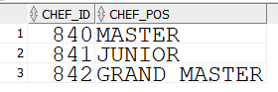

select * from supplier;

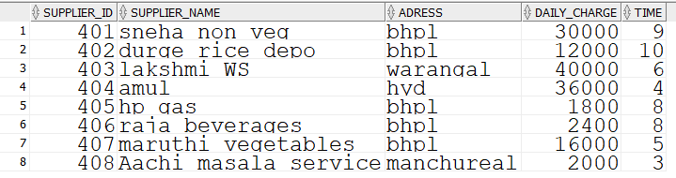

select * from supplies;

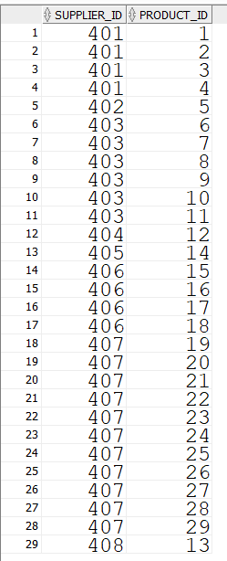

select * from occupy;

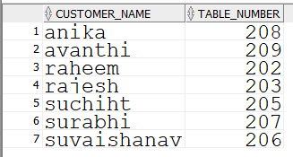

select * from others;

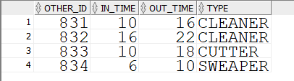

select * from weighter;

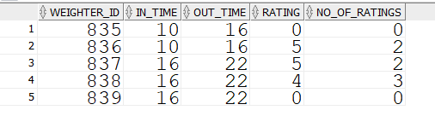

select * from makes;

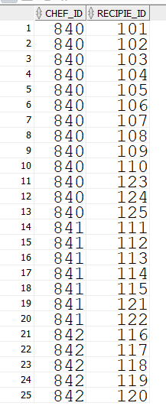

select * from recipies;

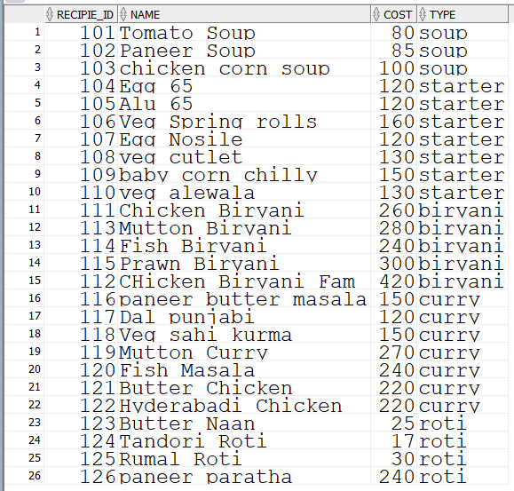

select * from requirements;

RECIPIE_ID,PRODUCT_ID,QUANTITY

101,23,1

101,21,2

101,7,3

102,12,2

102,21,2

102,7,7

103,7,3

103,10,4

103,21,1

104,13,1

104,9,3

104,25,1

105,29,3

105,13,1

106,6,1

106,7,5

106,19,6

106,20,7

106,21,4

107,25,1

107,13,1

107,24,1

108,9,6

108,20,1

108,21,1

108,22,1

108,23,6

109,27,1

109,28,1

109,13,3

110,20,1

110,21,1

110,22,8

110,23,2

111,1,1

111,5,9

111,13,1

111,21,5

112,1,2

112,5,5

112,13,1

112,21,5

113,2,6

113,5,4

113,13,3

113,21,1

114,3,1

114,5,2

114,13,1

114,21,1

115,4,3

115,5,1

115,13,1

115,21,4

116,10,1

116,12,6

116,13,1

116,14,6

117,28,1

117,10,2

117,23,1

117,13,1

118,10,2

118,21,1

118,22,1

118,23,1

119,2,1

119,23,1

119,10,3

119,21,1

120,3,3

120,10,1

120,13,1

120,21,4

121,10,2

121,1,1

121,13,1

122,1,1

122,10,1

122,13,1

123,9,5

123,6,6

124,9,7

124,6,4

125,9,2

126,12,1

126,9,1

126,6,1

select * from bills;



select * from payment_mode;

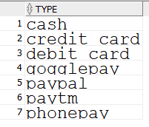

select * from product_neccessity;

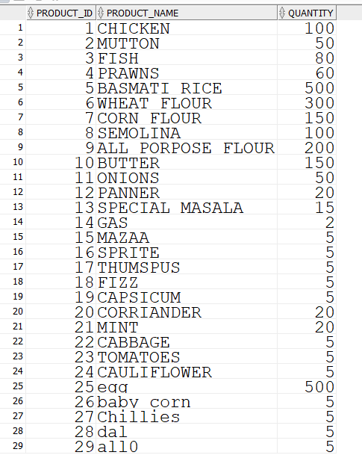

select * from staff;

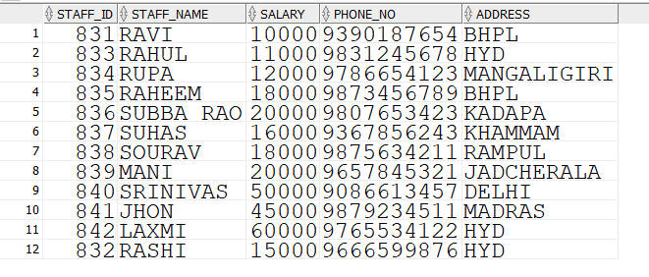

FINAL OVERVIEW ON PROJECT